CHALLENGE TEMPLATE

Title | /*A name for the challenge. A short but clear description of the problem to be solved*/  Corrosion Protection
Owner | /*The one responsible for the challenge proposal (not necessarily its original creator), who will be consulted about it when needed*/  First Name: Jean Pierre  Last Name: Goossens Alayon  e-mail: jeanpierre.goossensalayon@enel.com
Originator | /*The one from which the challenge proposal came from. The original Creator*/  First Name: Julio  Last Name: Antunez Lipez  e-mail: julio.antunez@enel.com
Function | /*The function which originated the challenge*/  O&M Peru
Country | /*The country which the challenge owner belongs to*/  Perú
Challenge Description | /*A description of the problem in detail, including what efforts to solve it have been taken in the past and why these efforts were unsuccessful*/  Many components of medium voltage overhead transmission lines are impacted by the accumulation of, and corrosion caused by, a combination of sea salt, moisture, dust, and industrial smoke.  This is particularly true in locations that receive little rain to wash the accumulation away, such as Lima, Peru. The infrequent mild drizzle in such places only leads to mud formation and impregnation of the components. A variety of components are affected, including polymer-porcelain insulators, copper or aluminum conductors, and steel staples, connectors, and cabinets.  Enel is seeking a method to prevent this build up and corrosion that can be utilized on existing components and potentially on new components. While a single method applicable across all component types is ideal it is recognized that the variety of different component types may require different methods and Solvers are encouraged to submit overall methods or methods specific to a component type.  Enel is interested in suggestions for commercially available products or easily implementable methods rather than solutions that require significant further development.
Constraints | /*A list of requirements that the solution, which will be investigated by the Innovation process, should respect to solve the challenge (separate them into “must have” and “nice to have”)*/  - Compatibility to already installed components on the network with advanced corrosion conditions. (Must have)  - No components that require a laboratory support to be applied. (Must have)  - Duration of at least two years after a single application/use. (Must have)  - Costs lower than (per component):  - Staple - $2.00 (Must have)  - Cut-out - $3.00 (Must have)  - Possibility for the Seeker client to have “freedom to practice” or be available for potential licensing. (Must have)  - No third party patent art preventing the use of specific equipment and materials for their commercial application. (Must have)  - Applicability to new components. (Nice to have)
Expected Benefits | /*A list of benefits that the innovative solution described above would bring*/  - Reduction of outages due to devices breakdown (improvement of QoS, avoiding penalties);  - Reduction of maintenance costs (frequency of maintenance teams’ intervention);  - Reduction of devices substitutions per year.
Key Performance Indicators (KPI) | /*Which KPIs (or other objective type of index) should be considered while evaluating the solution’s effectiveness*/  - OPerational EXpenses (OPEX)  - SAIFI (QoS index)  - SAIDI (QoS index)
Notes | /*A space for any additional information that didn’t fit the boxes above*/
Attachments | /*Additional material/pictures/block diagrams/… that would help in understand the issue*/  The following pictures show the effect of pollution on different types of devices:  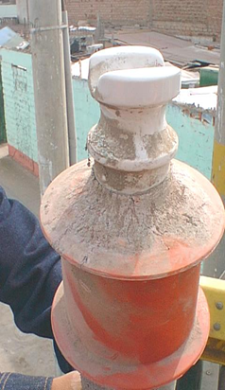  Insulator  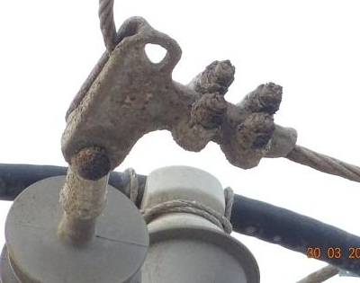  Staple  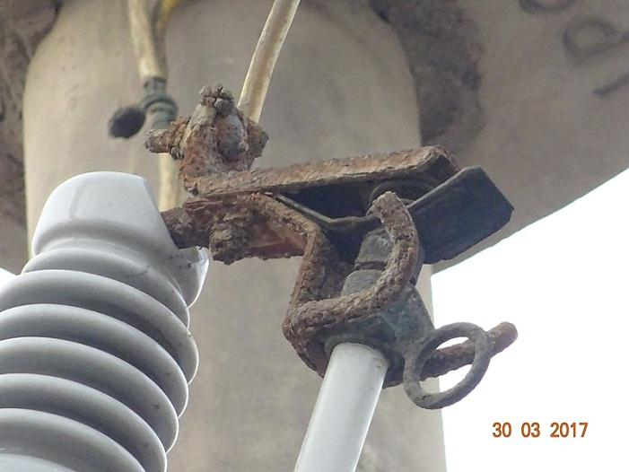  Cut-Out Disconnector

